The Department of Radiology and Biomedical Imaging at the University of California San Francisco is expanding the breadth and depth of the existing research program based at the VA Medical Center in San Francisco. In support of this expansion the Department is opening a search for several faculty positions for Imaging Scientists who will work closely with clinical faculty to develop powerful new capabilities in translational imaging.

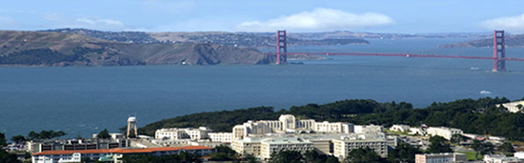The faculty positions will be based at the VA San Francisco, one of the teaching hospitals of the University of California San Francisco Medical System, and home to the largest research program in the Department of Veterans Affairs.

The appointees will have their academic positions at the University of California San Francisco (UCSF). UCSF is one of the world's leading biomedical research institutions, with excellence in both the scientific and clinical arenas.

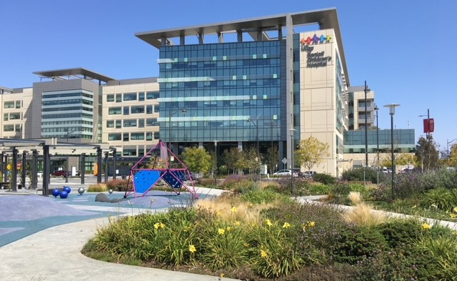
The University is keenly interested in the creation of new knowledge and making such knowledge available in the world of health care through education and technology transfer. UCSF has more than a thousand PIs and 3,000 ongoing research projects and is the largest recipient nationwide of grants from the National Institutes of Health. Of all Schools of Medicine UCSF’s is the largest recipient of NIH funding. The Department of Radiology and Biomedical Imaging has ranked in the top 4 recipients of NIH funding for a number of years.

VA Radiology Faculty
Michael Hope, MD
Chief of Radiology
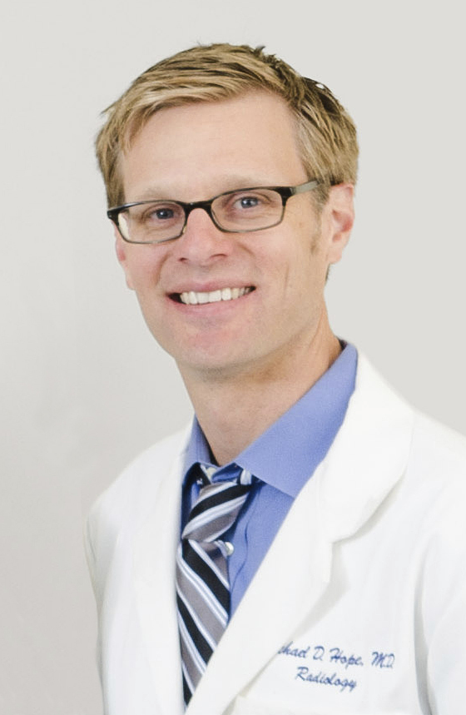
Research Interest:
Assessment of aortic disease
Dieter Meyerhoff, PhD
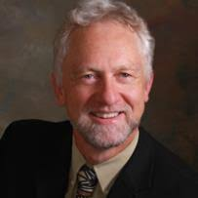
Research Interest:
Imaging in Substance Abuse
Linda Chao, PhD
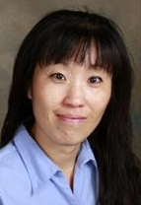
Research Interest:
Traumatic brain injury
Thomas Hope, MD
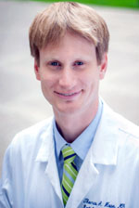
Research Interest:
Multi-modality imaging

David Saloner, PhD
Research Interest:
Vascular Disease
Pratik Mukherjee, MD
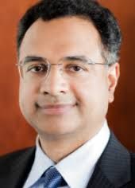
Research Interest:
Neural networks
Susanne Mueller, MD
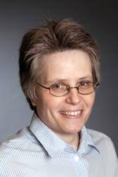
Research Interest:
Neural structure and epilepsy
Rajiv Sahwney, MD
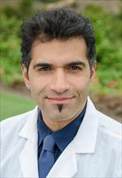
Research Interest:
Interventional procedures

Stefanie Weinstein, MD
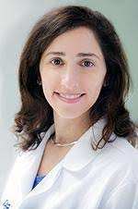
Research Interest:
Ultrasound contrast agents
Michael Weiner, MD
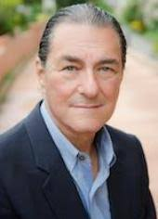
Research Interest:
Neurodegenerative disase
Duygu Tosun-Torgut, PhD
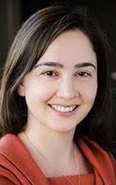
Research Interest:
Image processing
Ramya Srinivasan, MD
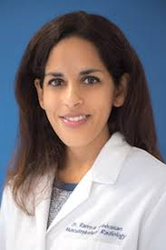
Research Interest:
Muskuloskeletal disorders

Resources: The VA Medical Service has substantial infrastructure in place to support advanced imaging programs. This includes: 3T and 7T MR scanners that are dedicated for research; clinical 3T and 1.5T MR scanners; PET-CT; CT scanners; and US scanners.
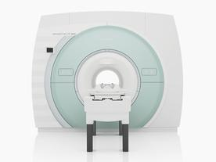

In addition, there are robust research programs throughout the Medical Center and strong collaborative opportunities with clinician scientists across the enterprise. These include teams working in areas relevant to the positions being sought: Cardiovascular Disease (Vascular and Neuro Surgery; Cardiology and Cardiac Surgery); Muskuloskeletal Disease (Orthopedic Surgery, Endocrinology); and Big Data (Epidemiology). Scientists at the VA are also eligible to apply for research support from the VA funding sources.

Researchers in the VA system are in a unique position to engage in investigations in a not-for-profit Medical Center providing comprehensive access to the veteran population. Patients in the VA system enjoy consistent long-term coverage, and understand the value of participating in longitudinal studies that help clinicians monitor their health status. The electronic record of the VA system also facilitates the assembly of large patient data bases that permit an analysis of the drivers of disease and the response to therapies.

Broader opportunities exist for interactions with UC Berkeley, principally through the Bioengineering Graduate Group, and with the Lawrence Berkeley and Lawrence Livermore National Laboratories.

The VAMC is located at the tip of the San Francisco peninsula and has a picturesque setting overlooking the Golden Gate Bridge. It is situated in San Francisco, one of the most desirable cities in North America, and is close to wine country, ski slopes, and coastal destinations.

Positions: Depending on the qualifications of the applicants, positions will be open at the level of Assistant, Associate, or Full Professors in either the In Residence or Adjunct Professor tracks.

Areas of expertise: Candidates with expertise in musculoskeletal imaging, vascular imaging, or big data as it relates to imaging studies, will be given special consideration. However, given the breadth of expansion, candidates who excel in other in vivo imaging areas will also be considered.

Position funding: Each position will have partial hard money support from the VA Medical Center.

Expectations: The successful applicants will be expected to build a research program of excellence. It is expected that they will join a highly collaborative community of imaging scientists focused on creating novel methodologies to make real and lasting changes in translational imaging – imaging that will be implemented into the clinical routine with important benefits to the health and well-being of the patient population that we serve. Depending on their academic track, they will also be expected to engage in teaching and to have a strong engagement with the functioning of the academic medical center.

